Year 10 · Cambridge IGCSE

NAME

CLASS |  |  | DATE

COMPUTER SCIENCE 0478
Paper 2 Algorithms, Programming and Logic
Trace Tables: Exam Questions about 1 hour 30 minutes
Answer on the question paper.

INSTRUCTIONS
- Answer all questions.
- Complete each trace table one step at a time. Only write a value in a column when that variable changes or a new value is input or output.
- Start a new row whenever you need to; you may not need every row.
- Calculators must not be used.

INFORMATION
- The total mark is 67.
- The number of marks for each question or part question is shown in brackets [ ].
- The questions use FOR, WHILE and REPEAT loops, IF and CASE selection, and one-dimensional arrays, in both pseudocode and flowcharts.

For teacher use
Question | 1 | 2 | 3 | 4 | 5 | 6 | 7 | 8 | Total
Marks | 6 | 7 | 7 | 7 | 8 | 11 | 9 | 12 | 67
Score

This document has 13 pages.
1 This section of program code may be used as a validation check.
1 OUTPUT "Input a value between 0 and 100 inclusive"
2 INPUT Value
3 WHILE Value < 0 OR Value > 100 DO
4 OUTPUT "Invalid value, try again"
5 INPUT Value
6 ENDWHILE
7 OUTPUT "Accepted: ", Value
(a) Give a name for this type of validation check.
[1]
(b) Describe what is happening in this validation check.

[2]
(c) Complete the trace table for this program code using the test data:
200, 300, –1, 50, 60 [3]
Value | OUTPUT

2 The pseudocode represents an algorithm.
The pre-defined function DIV gives the value of the result of integer division. For example, Y = 9 DIV 4 gives the value Y = 2
The pre-defined function MOD gives the value of the remainder of integer division. For example, R = 9 MOD 4 gives the value R = 1
First ← 0
Last ← 0
INPUT Limit
FOR Counter ← 1 TO Limit
INPUT Value
IF Value >= 100
THEN
IF Value < 1000
THEN
First ← Value DIV 100
Last ← Value MOD 10
IF First = Last
THEN
OUTPUT Value
ENDIF
ENDIF
ENDIF
NEXT Counter
(a) Complete the trace table for the algorithm using this input data:
8, 66, 606, 6226, 8448, 642, 747, 77, 121 [5]
Counter | Value | First | Last | Limit | OUTPUT

(b) Describe the purpose of the algorithm.

[2]

3 This algorithm makes sure that there are enough fresh bread rolls available for customers to buy.
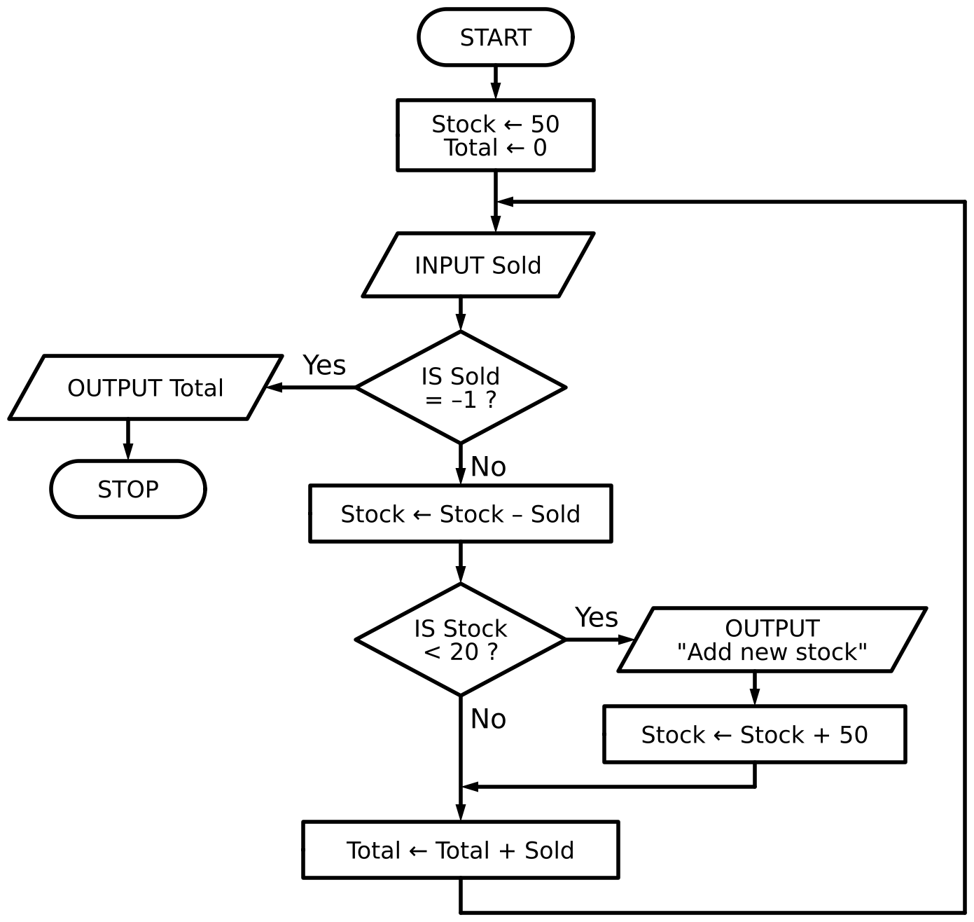
(a) Complete the trace table for the algorithm using this input data:
24, 12, 6, 30, 12, 18, –1, 24 [4]
Sold | Stock | Total | OUTPUT

(b) Identify the problem that will occur if the input data starts with a value of 70. Explain how you would correct this problem.

[3]
4 The algorithm stores some examination marks in the array PassMarks.
Index ← 0
FOR Count ← 0 TO 7
INPUT Value
IF Value > 50
THEN
PassMarks[Index] ← Value
Index ← Index + 1
ENDIF
NEXT Count
OUTPUT "Number passed ", Index
(a) Complete the trace table for this algorithm using the input data:
58, 40, 67, 85, 12, 13, 75, 82 [6]
Index | Count | Value | PassMarks |  |  |  |  |  |  |  | OUTPUT
Index | Count | Value | [0] | [1] | [2] | [3] | [4] | [5] | [6] | [7] | OUTPUT

(b) Give the purpose of the algorithm shown in part (a).

[1]

5 This is an algorithm to find if a batch of parts has been manufactured successfully.
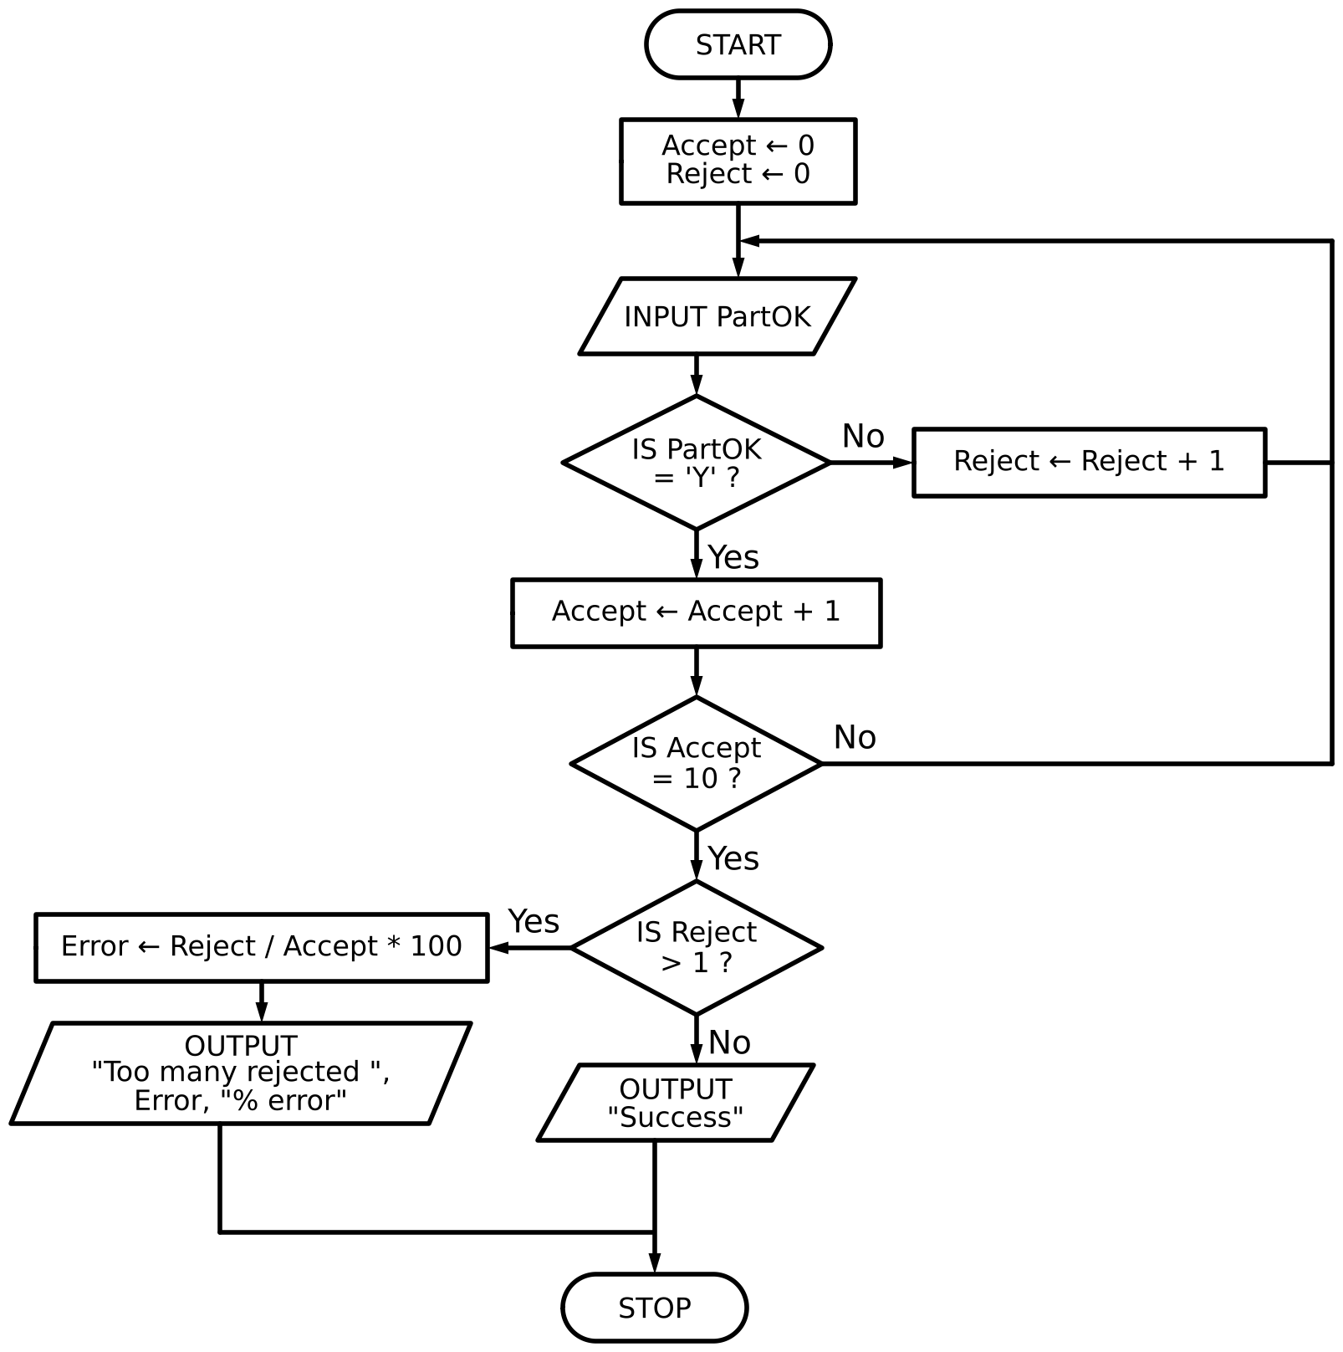
(a) Complete the trace table using this data:
Y, Y, Y, N, Y, Y, Y, Y, N, Y, Y, Y, Y [5]
Accept | Reject | PartOK | Error | OUTPUT

(b) Describe how the algorithm should be changed to accept ‘Y’ or ‘y’ for a successfully manufactured part.

[3]

6 A clothes shop uses this algorithm to count the sizes of T-shirts sold in a day.
Each size is input as a single character. An input of 'X' ends the input.
DECLARE Size : CHAR
DECLARE Index : INTEGER
DECLARE Total : ARRAY[1:4] OF INTEGER
FOR Index ← 1 TO 4
Total[Index] ← 0
NEXT Index
REPEAT
INPUT Size
CASE OF Size
'S' : Total[1] ← Total[1] + 1
'M' : Total[2] ← Total[2] + 1
'L' : Total[3] ← Total[3] + 1
OTHERWISE : Total[4] ← Total[4] + 1
ENDCASE
UNTIL Size = 'X'
FOR Index ← 1 TO 3
OUTPUT Total[Index]
NEXT Index
OUTPUT "Invalid: ", Total[4]
(a) Complete the trace table for the algorithm using this input data:
M, L, M, S, Q, M, X, S [6]
Index | Size | Total |  |  |  | OUTPUT
Index | Size | [1] | [2] | [3] | [4] | OUTPUT

(b) State the purpose of the algorithm.

[2]
(c) There is a logic error in the algorithm. The final output is one more than the number of invalid sizes that were input.
Identify the cause of the error and describe how the algorithm could be corrected.

[3]

7 This algorithm checks the temperature of hot food being served to customers.
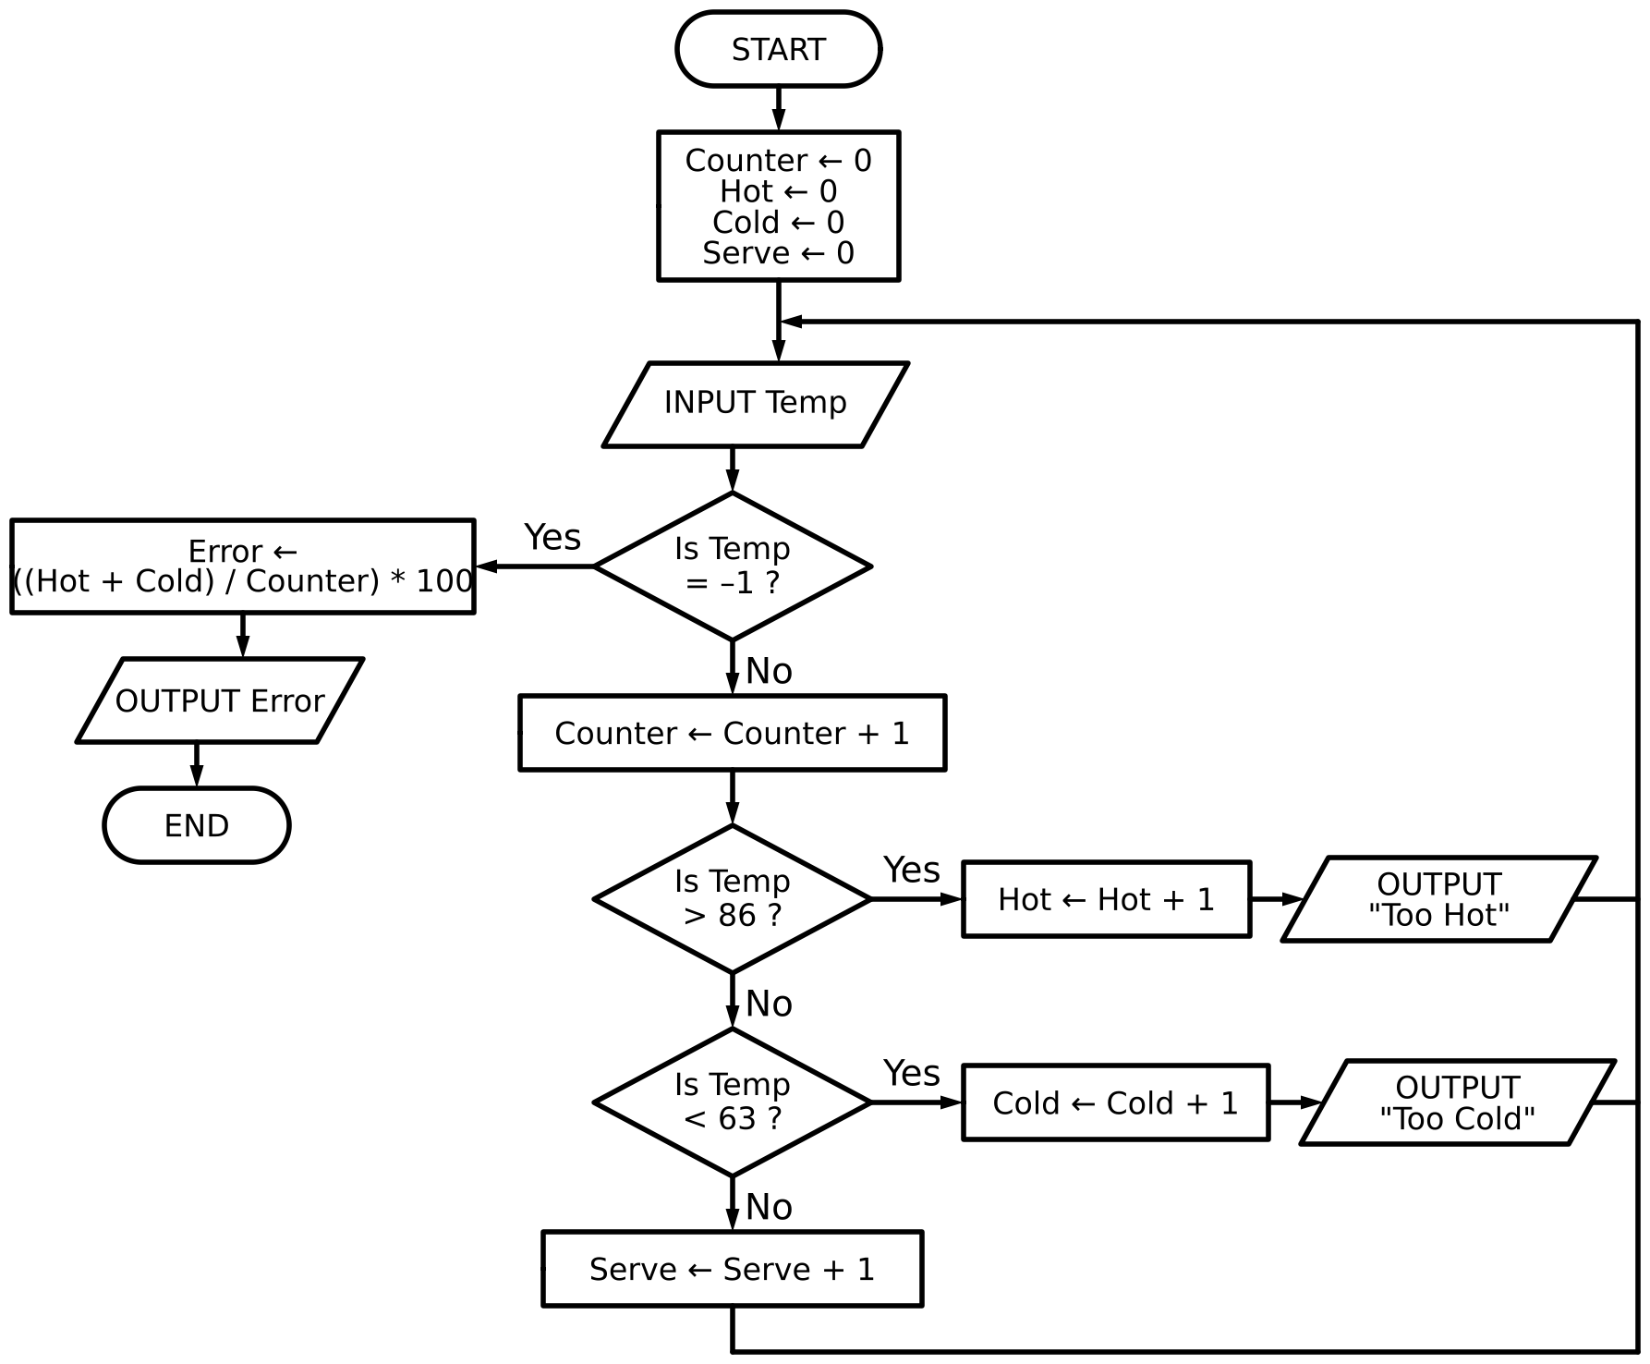
(a) Complete the trace table for the algorithm using this input data:
75, 78, 84, 87, 91, 80, 75, 70, 65, 62, –1, 20 [7]
Counter | Hot | Cold | Serve | Temp | Error | OUTPUT

(b) State how the final output from the algorithm could be improved.

[1]
(c) Identify the process in the algorithm that is not required.
[1]

8 The pseudocode represents an algorithm.
The pre-defined function DIV gives the value of the result of integer division. For example, Y = 11 DIV 4 gives the value Y = 2
Count ← 0
INPUT Limit
FOR In ← 1 TO Limit
Logic ← TRUE
Test ← 2
INPUT Number
REPEAT
IF Number / Test = Number DIV Test
THEN
Logic ← FALSE
ELSE
Test ← Test + 1
ENDIF
UNTIL NOT Logic OR Test >= Number DIV 2
IF Logic
THEN
Store[Count] ← Number
Count ← Count + 1
ENDIF
NEXT In
FOR Out ← 0 TO Count - 1
OUTPUT Store[Out]
NEXT Out
(a) Complete the trace table for the algorithm using this input data:
5, 9, 5, 8, 10, 7 [7]
In | Logic | Test | Number | Store[Count] | Count | Limit | Out | OUTPUT

(b) State the purpose of this algorithm.

[2]
(c) This algorithm only works for numbers that are 3 or greater. Describe how you could change this algorithm to make sure that only numbers that are 3 or greater are entered. Any pseudocode statements used in your answer must be fully described.

[3]

END OF QUESTIONS

